**[Web Services Directory](https://1d8723.github.io/FBI/webservice/)**[**http://bit.ly/1D8726**](http://bit.ly/1D8726)

**Internet Payments**

**$uri = "https://ics2wsa.ic3.com/commerce/1.x/transactionProcessor/CyberSourceTransaction_1.207.wsdl"**

**$visa = New-WebServiceProxy -Uri $uri**

**$visa | Get-Member -MemberType method**

Name MemberType Definition

---- ---------- ----------

runTransaction Method void runTransaction

runTransactionAsync Method void runTransactionAsync

[[more]](https://learn.microsoft.com/en-us/powershell/module/microsoft.powershell.management/new-webserviceproxy?view=powershell-5.1)

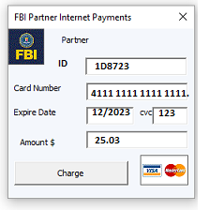

Web Service

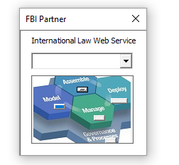

Windows Application (Calculator)

$URI = "http://www.dneonline.com/calculator.asmx?wsdl"

$calc = New-WebServiceProxy -Uri $URI -Namespace "WSProxy" -Class "Calculator"

$calc | Get-Member -MemberType method

$calc.Multiply(6,7)

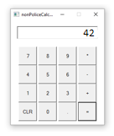

[**Application**](https://1d8723.github.io/FBI/webservice/)

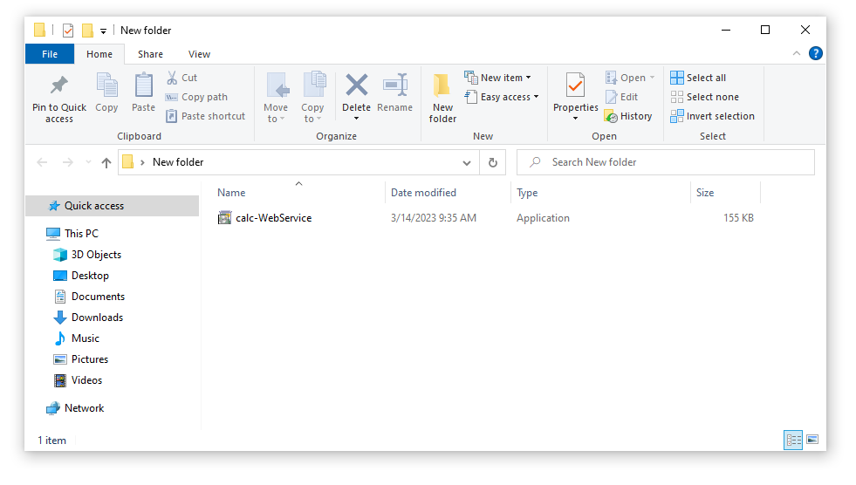

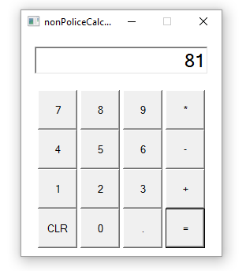

**iExpress.bat calc-WebService.bat calc-WebService.exe**

**calc-WebService.bat**





**iExpress.bat**



@1D8723 ➜ /workspaces/FBI (development) $ cd /opt/IBM/WebSphere/AppServer/profiles/AppSrv01/

@1D8723 ➜ .../AppServer/profiles/AppSrv01/bin $ ./startServer.sh server1

/workspaces/FBI

./contextPath -f contextPath.cfg

./haproxy -f haproxy.cfg

